Software Requirements Specification for
MetaKart - an online shopping service

Prepared by:

Name | Roll.No | Email ID
Ronit Yemul | 7108 | ronityemul12@gmail.com
Priyanka Bane | 7047 | priyankabane56@gmail.com
Karthick V Arya | 7046 | karthickarya09@gmail.com
Varun Bhatt | 7049 | bhattvarun29@gmail.com

Introduction :
MetaKart is an online shopping service that provides users access to a wide range of products online. The users can order products to their doorstep from any mobile device or computer with access to the internet.

Following are the modules which we had implemented regarding to our project:
Software Requirement Specifications :
The online shopping-cart application is a web-based system. It can be accessed using Internet Explorer 8.0 and above, Mozilla Firefox 2.0, and Google Chrome.
- User Interface
The two interface types found in the online shopping-cart application are as follows:
1. User Interface: Users are able to view the home page of the shopping-cart application, browse the different categories, browse and add any number of items from any categories in the shopping cart, look for information about each product, delete the items in the shopping cart, save the cart for later viewing, check out or continue shopping after adding the item to the cart, and check out the items by completing the required information in the order form.
2. Admin Interface: The administrator is able to view the users’ information that was entered during checkout in the database, can update the information, price, shipping costs of the items, add or remove items from the main display.
- Hardware Interface
The online shopping-cart application shall provide minimum hardware requirements. The following hardware configurations are required for a PC using the online shopping-cart application:
Any hardware that can run a supported browser mentioned below
- Software Interface
This section lists the requirements that are needed to run the system efficiently. The operating system needed for the system to run effectively, the interface to run the application, the driver for running Java web applications, the integrated development environment to develop the application, and the third-party tool used for editing purposes are as follows:
1. Operating System: Windows (Vista/Windows 7) or MAC OS, Linux or any other OS that supports the following browsers
2. Web Browser: Microsoft Edge, Google Chrome, Firefox, Safari.

Delivered product will have the following requirements:
Functional Requirements:
This section contains the requirements for the online shopping-cart application. The functional requirements, as collected from the users, have been categorized as follows to support the types of user interactions that the system shall have.
- User: View Categories and Items: The users shall be able to see the home page of the online shopping-cart application when they first run the program. The users shall be able to view the different categories, select categories, browse through the items in each category, and add items to the shopping cart. The users shall be able to view the shopping cart and more information about each item.
FR01: The users shall be able to view the categories on the application’s home page.
FR02: The users shall be able to view items in different categories.
FR03: The users shall be able add items to the cart.
FR04: The users shall be able to view more information about an item before adding it to the cart.
FR05: The users shall be able to able view the shopping cart.
FR06: The users shall be able to browse through the available items.
- User: View Shopping Cart: After the first run of the application, the users shall be able to see their designated home page. After browsing through the items and adding items to the shopping cart, the users should be able to view the items in the shopping cart. The users shall be able to check out or continue shopping. The users shall be able to delete items from the cart.
FR07: The users shall be able to view the items added to the cart.
FR08: The users shall be able to check out with the current items in the cart.
FR09: The users shall be able to continue shopping.
FR10: The users shall be able to delete items from the cart.
- User: Checkout Items
FR11: The users shall be able to check out items only when there are items in the shopping cart.
- Login/ User Authentication
FR12: The users shall login or register using the user authentication form.
FR13: The users shall not login or register if the information is incomplete or invalid.
- User: Place Order
FR14: The users shall place an order by completing the information in the order form.
FR15: The users shall not be able to place an order if the information in the order form is invalid or incomplete.
- Admin: View User Information
FR16: The administrator shall be able to view all the users’ information that completes the order form and the checkout process.
- Admin: Add/Update/Delete Shopping Items
FR17: The administrator shall be able to add new items to the list of shopping items.
FR18: The administrator shall be able to modify/update an item’s price and description.
FR19: The administrator shall be able to delete items from the main page of the shopping-cart application.
Performance Requirements
This section lists the performance requirements expected from the online shopping-cart application.
PR01: The users shall be able to add an item to the cart in fewer than 10 seconds.
PR02: The users shall be able to view information about an item in fewer than 15 seconds.
PR03: The users shall be able to check out the items in the shopping cart within 10 seconds
after completing the order form.
PR04: The navigation between pages shall take fewer than 5 seconds.
PR05: The application shall be able to do a validation check on the information provided information.
Safety and Security Requirements
- The user details of the customers and sellers will be safely stored in database.
- The transaction will take place through secure channel using https and the details will not be revealed to other users or parties.
- This application uses a distributed database in order to avoid dependencies, provide security and to provide backup and fail safe option to the data in the database.
- Users will be given access only when the authentication of their identity is established through username login

Cost Estimation Methods :
- Function Point Analysis :
The purpose of Function Points is to produce an estimate of software size from software requirements. Function Points are an indirect measure of software size based on external and internal application characteristics, as well as application performance. Function Points have a significant cost estimating relationship (CER) to software costs.

1.DETERMINING UNADJUSTED FUNCTION POINT COUNT
Determining the unadjusted function point count consists of counting the number of external inputs, external outputs, external inquiries, internal logical files, and external interface files.
- External Inputs: Home page contains add to cart and view product button as well as login form on the nav bar. Login form contains two input text fields and a button. Once user is logged in there is a button to view cart and 1 to sign out. Seller also has the option to add an item. Add item form has 5 inputs and a button. Cart has button to proceed to checkout and also remove items from cart. Sign up page contains three input fields and two buttons. Forgot password page contains two input fields and a button. Checkout process includes three fields and a button . Therefore weighted average external inputs = 27*3 = 81

- External Outputs: Two output pages exist, one that displays product details and one that displays check out success. Therefore weighted average external outputs = 2*5=10

- External Inquiries: There are no External Inquiries for this application.

- Internal Logical Files: There are 8 Internal Logical Files namely - product list, cart, add item, login, Sign up, password reset, checkout and product details. The Internal Logical Files will be rated Low, therefore multiplied by 7, for a weighted Internal Logical Files of 56.
- External Interface Files: There are no External Interface Files for this application.

The Unadjusted Function Point Total is therefore is = 81+10+56 = 147
2. DETERMINING VALUE ADJUSTMENT FACTOR
- 1. Does the system require reliable backup and recovery?
Value:3
- 2. Are specialized data communications required to transfer information to or from the application?
Value:3
- 3. Are there distributed processing functions?
Value:1
- 4. Is performance critical?
Value:4
- 5. Will the system run in an existing, heavily utilized operational environment?
Value:3
- 6. Does the system require online data entry?
Value:3
- 7. Does the online data entry require the input transaction to be built over multiple screens or operations?
Value:4
- 8. Are the ILFs updated online?
Value:3
- 9. Are the inputs, outputs, files, or inquiries complex?
Value:3
- 10. Is the internal processing complex?
Value:2
- 11. Is the code designed to be reusable?
Value:3
- 12. Are conversion and installation included in the design?
Value:1
- 13. Is the system designed for multiple installations in different organizations?
Value:0
- 14. Is the application designed to facilitate change and ease of use by the user?
Value:4
- ∑ (Fi )=3+3+1+4+3+3+4+3+3+2+3+1+0+4=37
The Value Adjustment Factor is therefore is 37.

3. DETERMINING FUNCTION POINTS
FP = unadjusted function points* (0.65 +0.01 * ∑ (Fi ) )
= 147*(0.65+0.01*37)= 149.94

The total lines of code for the language(JSP) that we are using is as follows: FP*LOC =149.94*63=9446
The function point for Shopping Application is 149.94 and total lines of code=9446

- Cocomo Model:
COCOMO stands for Constructive Cost Model, a method for evaluating and/or estimating the cost of software development.
Assume that the size of a software product has been estimated to be 2,000 lines of source code.
Now, we will go for overall estimation of project. If we analyzing our project, then we find that shopping application is a Semi-detached project. So, for estimation purpose we will make use of those constants.

E = Ab KLOCBb

D=CbEDb

E = Effort applied in person months
D = Development time in chronological months
E = 3.0 X (2)^1.12
= 6.52 Person Months
D = 2.5 X (6.52)^0.35
= 4.81 Months
N = E/D => Number of people
= 6.52/4.81
= 1.4 ≈ 2
For completion of this project we will require 2 people.

Risk Analysis:
Risk analysis is done with the help of risk table and study of RMMM(Risk Mitigation, Monitoring and Management Plan) plan.
A risk table is a list of all the risks that could affect your software project. A risk is an event that is not guaranteed to happen (i.e. not 100%) that if triggered would affect your project positively or negatively. A risk table provides a project manager with a simple technique for risk projection.
For our project, We had encountered with five types of risks.
1)System Crash
2)Lack of development issue
3)Poor comments in code
4)Changes in software requirements
5)Late delivery of the project

For each of the above risks , we had identified the category to which the given risk belongs.i.e. Late delivery and Requirement changes comes under business impact whereas rest of the risks are categorized as technical issues.
After identification of each risk , what could be the impact of the risk , what can be the probability of risk occurrence and what amount of risk exposure it could lead to - all these factors have been documented .Report date for the risk is noted down.
Further who was responsible for the risk to occur , when did the risk recovery started and completed is mentioned correctly during the risk analysis phase.Mitigation approaches and contingency plans for the respective risks have been followed.Finally what is the current status of the occurred risk is been seen.
The detailed risk documentation can be seen in Experiment No.4.

Risk Documentation Form

Risk ID:001 | Classification: Technical Issue: System Crash. | Report Date:02/02/2016
Description:The reason for the crash is unstable software running on the client.

Probability: 30% | Impact: Data loss and the system goes into an inconsistent state. | Risk Exposure: 0.3*80 = 24
First Indicator:System going into an unresponsive state.
Mitigation Approaches:Use a dependable system and framework to avoid this problem.
Date Started:03/02/2016 | Date to Complete: 05/02/2016 | Owner:Karthick Arya
Current Status:The mitigation plan holds good. It has been successful in avoiding system crashes till date.
Contingency Plan: Backup the data and if the system crashes recover the data from the backup DB.
Trigger for Contingency Plan:Take backup regularly to avoid the problem.

Risk ID:002 | Classification: Technical Issue: Lack of development Experience | Report Date:20/01/2016
Description: The group developing the project lack experience with the technologies used.

Probability:30% | Impact: The project may not be finished on time and the application developed will not be efficient. | Risk Exposure: 0.3*40 = 12
First Indicator:Slow progress in initial development phases.
Mitigation Approaches:Have good pre-requisites about the technologies which will be used in development, and get proper hands-on experience with the technologies.
Date Started:20/01/2016 | Date to Complete: 1/02/2016 | Owner:Varun Bhatt
Current Status:The people involved in the project have a good experience with the technologies used.
Contingency Plan: Try to clear the basics if a person faces a problem.
Trigger for Contingency Plan:Person has no clue about how to progress with the project.

Risk ID:003 | Classification: Technical Issue- poor comments in code | Report Date:02/03/2016
Description:The reason for poor comments in code is good commenting standards were not followed.
Probability: 20% | Impact: Code becomes difficult to maintain and update. | Risk Exposure: 0.2*20= 4
First Indicator:Poor quality of code understandability.
Mitigation Approaches:Development of formal written standard to ensure quality of comments.
Date Started:03/03/2016 | Date to Complete: 10/03/2016 | Owner: PriyankaBane
Current Status: Careful monitoring is going with special attention given to the comments.
Contingency Plan: Code review should be done on a daily basis.
Trigger for Contingency Plan:Comment quality began to drop and refining the comments becomes difficult.

Risk ID:004 | Classification: Business Impact– Changes in requirements | Report Date:15/02/2016
Description:The reason for changes in requirements is insufficient communication with the customer.
Probability:20% | Impact: Inefficient requirement gathering phase. | Risk Exposure: 0.2*50=10
First Indicator:Customer was unhappy with gathered requirements. All of his requirements were not covered by our project.
Mitigation Approaches:Development of formal written standard to ensure quality of comments.
Date Started:16/03/2016 | Date to Complete: 20/03/2016 | Owner: Ronit Yemul
Current Status: Formal as well as informal meetings are held with the customer on a routine basis to know customer's update on his requirements.
Contingency Plan: Try to understand the customer's view for his necessary product requirements .
Trigger for Contingency Plan: Development team's idea about the product differs with thecustomer's idea on his product.

Risk ID:005 | Classification: Business Impact: Late delivery | Report Date:02/04/2016
Description:The reason for late delivery is the delayed start of the project work.
Probability: 25% | Impact:Receiving failing grade for the respective project. | Risk Exposure: 0.25*80 = 20
First Indicator:Failed to submit the first weekly report for our project.
Mitigation Approaches:Steps have been taken to ensure the timely delivery based on the project deadline.
Date Started:03/04/2016 | Date to Complete: 05/04/2016 | Owner:Karthick,Priyanka,Ronit,Varun
Current Status: Project report has been submitted based on the weekly work done.
Contingency Plan: Try to request the professor for the extension of a deadline.
Trigger for Contingency Plan: Professor refused to check the project report due to missed deadline.

Project Scheduling:
In project management, a schedule is listing of a project's milestones, activities, and deliverables, usually with intended start and finish dates. Those items are often estimated by other information included in the project schedule of resource allocation, budget, task duration, and linkages of dependencies and scheduled events. Thus for completion of any project a proper project schedule is required.
In project scheduling of our project, we first defined the tasks to be completed for the entire project, we then decided the time required to complete each task and their dependencies.
After deciding the time required to complete each task, we allotted roles to each of the group members for completion of the project.
Each task was then allotted resources for individual completion of every task.
After knowing the deadlines and non-working days a Gantt chart was created, which gave the overview of the entire project.

Screenshots:

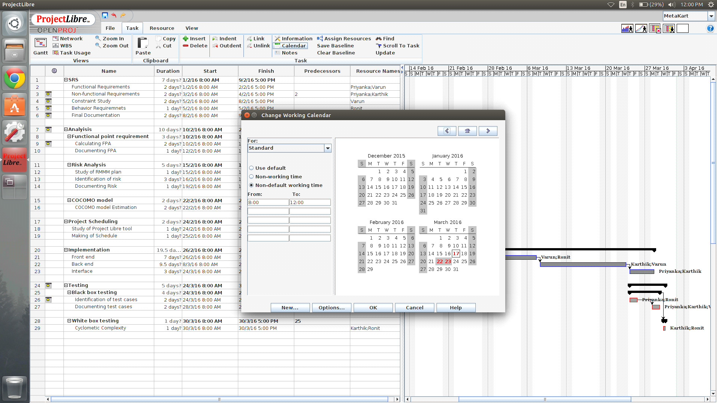

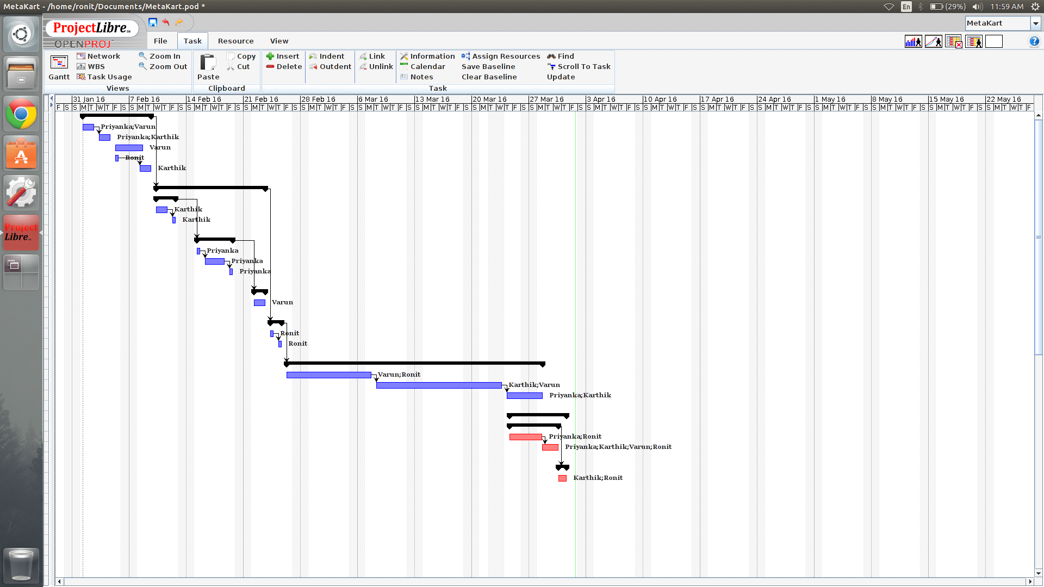

Black Box Testing:
Black box testing (also called behavioral/functional testing), focuses on the functional requirements of the software. The test designer selects valid and invalid inputs and determines the correct output. There is no knowledge of the test object's internal structure.
Different test cases have been identified for our project based on a particular module that has been implemented in the project.
After defining the test case , priority is been decided i.e. medium,low or high. Test description needs to be given in order to understand the test case properly.
Accurate preconditions and postconditions should be provided in order to verify the test case from start to end i.e. how the test case will be checked with valid inputs and how the test case will be resolved if it fails with invalid input set.
After the test case is defined, steps to execute the test and the test data provided to it is identified.Then the expected result from that test case is documented first and after that the actual result our project will yield is seen. Expected and the actual results are then compared to decide whether test case results is pass or fail during the actual implementation of the project.If their are some additional comments regarding the test then we can note it down.
Detailed test case documentation is dealt in experiment no.5.

Test Case ID: 001 | Test Designed by:
Test Priority (Low/Medium/High): High | Test Designed date:
Module Name: User login page | Test Executed by:
Test Title: Verify login with valid username and password | Test Execution date:
Description: Test the User login page
Pre-conditions: User should have valid username and password.
Dependencies:

Step | Test Steps | Test Data | Expected Result | Actual Result | Status (Pass/Fail) | Notes
1 | Test with valid username and empty password such that login must get failed | valid username and empty password | Proper error message must be displayed and prompt the user to enter login again. | Proper error message must be displayed and prompt the user to enter login again.
2 | Test with empty username and valid password such that login must get failed | empty username and valid password | Proper error message must be displayed and prompt the user to enter login again. | Proper error message must be displayed and prompt the user to enter login again.
3 | Test with empty username and empty password and check if login fails | Leave both the username and password fields empty. | Proper error message must be displayed and prompt the user to enter login again. | Proper error message must be displayed and prompt the user to enter login again.
4 | Check if the password is masked on the screen i.e., password must be in bullets or asterisks | password in the password field. | Proper error message must be displayed and prompt the user to enter login again. | Proper error message must be displayed and prompt the user to enter login again.

Post-conditions: User is validated with database and successfully login to account. The account session details are logged in database.

Test Case ID: 002 | Test Designed by:
Test Priority (Low/Medium/High): High | Test Designed date:
Module Name: User sign up page | Test Executed by:
Test Title: User sign up with all the necessary details | Test Execution date:
Description: Test the User sign up page
Pre-conditions: User wants to create a new account.
Dependencies:

Step | Test Steps | Test Data | Expected Result | Actual Result | Status (Pass/Fail) | Notes
1 | Checking the functionality of the "Username" field | A valid email-id with ‘@’ and’.’ | Verification of the account will be done by sending an email to the given email id. | Verification of the account will be done by sending an email to the given email id
2 | Check if the user has been verified through the provided email id | Entered a valid email-id | User will be notified with the verification link on his email and he has to click on the click in order to be the verified user. | User will be notified with the verification link on his email and he has to click on the click in order to be the verified user.
3 | Check if the user has verified the provided captcha or not | No verification for captcha | User will not be able to sign up for the account and he will be prompted to verify the given captcha. | User will not be able to sign up for the account and he will be prompted to verify the given captcha.
4 | Check if the User-Type fields is selected or not | No selection for the user-type field. | User will be prompted to select the user-type field.(It is compulsory) | User will be prompted to select the user-type field.(It is compulsory)
5 | Checking the behaviour by not filling any data in any of the fields | Leave the fields on sign up page empty | A proper error message should be shown and the user should be prompted to enter valid data | A proper error message should be shown and the user should be prompted to enter valid data
6 | Checking the behaviour by not filling any data in the username field | Leave the username field empty | User will be prompted to enter valid email id. | User will be prompted to enter valid email id.
7 | Check if the password field contains minimum 6 characters | A password with less than 6 characters. | An error message will be displayed saying that password must contain minimum 6 characters. | An error message will be displayed saying that password must contain minimum 6 characters

Post-conditions:
User is successfully signed-up and respective entries are made into the database.￼￼￼￼

Test Case ID: 003 | Test Designed by:
Test Priority (Low/Medium/High): High | Test Designed date:
Module Name: Product cart page | Test Executed by:
Test Title: User’s required payment related details | Test Execution date:
Description: Test the Product cart page
Pre-conditions: User wants to buy a product.
Dependencies:

Step | Test Steps | Test Data | Expected Result | Actual Result | Status (Pass/Fail) | Notes
1 | Check if the user has selected the payment method | No selection of any of the payment methods | User will be prompted to select any of the payment methods | User will be prompted to select any of the payment methods
2 | Test if the user has entered values in credit card number field and in CVV field | empty credit card number and empty CVV field. | User will be prompted to fill values in both the fields  (credit card no and CVV) | User will be prompted to fill values in both the fields  (credit card no and CVV)
3 | Test if the user has entered 16 digit credit card number or not | Credit card number with less than 16 digits. | User will be prompted to enter a proper 16 digit credit card number | User will be prompted to enter a proper 16 digit credit card number
4 | Test if the user has entered 3 digit CVV or not | CVV field having value less than 3 digits. | User will be prompted to enter a proper 3 digit CVV number. | User will be prompted to enter a proper 3 digit CVV number.
5 | Check if any one of the fields credit card number or CVV is empty. | No value in any one of the fields credit card number or CVV. | User will be prompted to enter the respective empty field. | User will be prompted to enter the respective empty field.

Post-conditions: User has successfully placed the order and its payment related details will be stored into the database.

Test Case ID: 004 | Test Designed by:
Test Priority (Low/Medium/High): Med | Test Designed date:
Module Name: Reset Password | Test Executed by:
Test Title: Reset password functionality available if user forgets the password | Test Execution date:
Description: Test the reset password functionality
Pre-conditions: User has forgot his old password or user wants to set a new password.
Dependencies:

Step | Test Steps | Test Data | Expected Result | Actual Result | Status (Pass/Fail) | Notes
1 | Checking if the user is able to reset the password or not | Clicked on reset password link | When user clicks on the reset password link, it gives an option to set a new password. | When user clicks on the reset password link, it gives an option to set a new password.
2 | Checking if the new password is of minimum 6 characters | New password with less than 6 characters | That password won’t be accepted and user will be prompted to provide a password with at least 6 characters | That password won’t be accepted and user will be prompted to provide a password with at least 6 characters
Post-conditions: User has successfully changed his password and the new password is been updated into the database.

Test Case ID: 005 | Test Designed by:
Test Priority (Low/Medium/High): Med | Test Designed date:
Module Name: ‘Search product’ page | Test Executed by:
Test Title: Searching products based on category selected | Test Execution date:
Description: Test the ‘Search product’ page
Pre-conditions: User wants to search a product having a specific category.
Dependencies:

Step | Test Steps | Test Data | Expected Result | Actual Result | Status (Pass/Fail) | Notes
1 | Checking if the products are shown category wise when the category name is selected | Selected a valid category name | When the specific category is given , all the products under that category are shown | When the specific category is given , all the products under that category are shown
2 | Checking if all products are shown when the category is not selected | No category selection | All the products will be shown to user having different categories. | All the products will be shown to user having different categories.
Post-conditions: User is been able to see a particular product of his choice.

SCREENSHOTS:
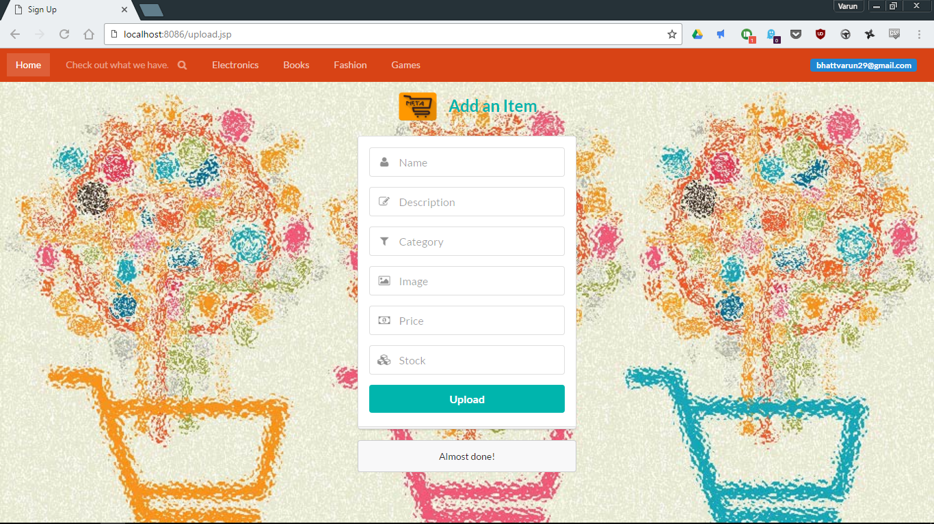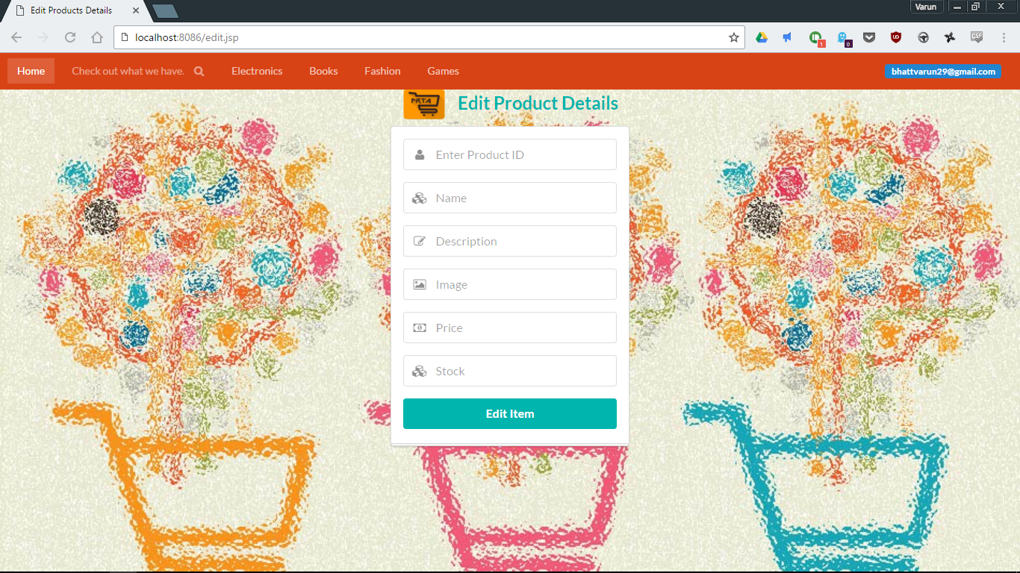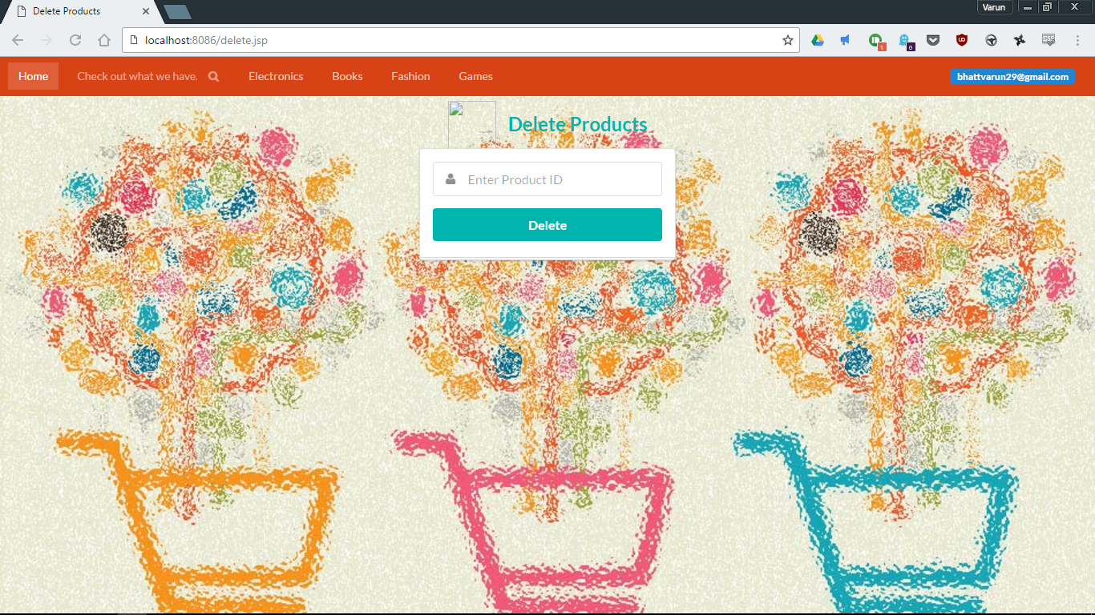
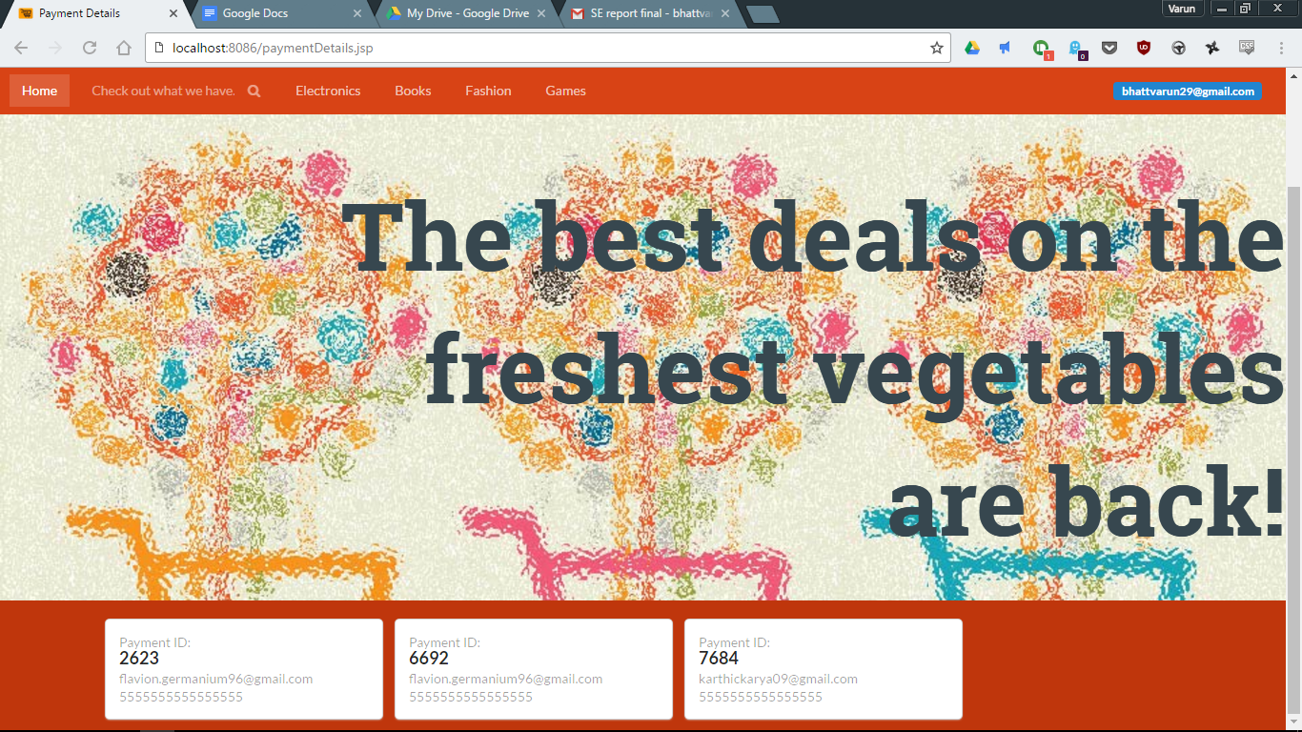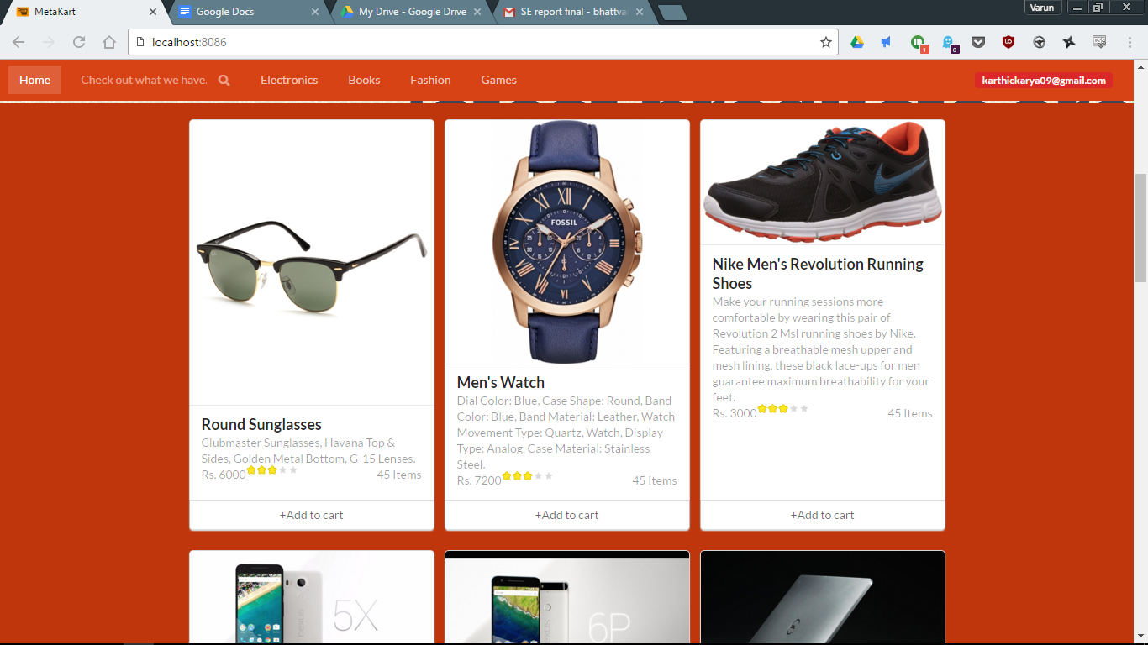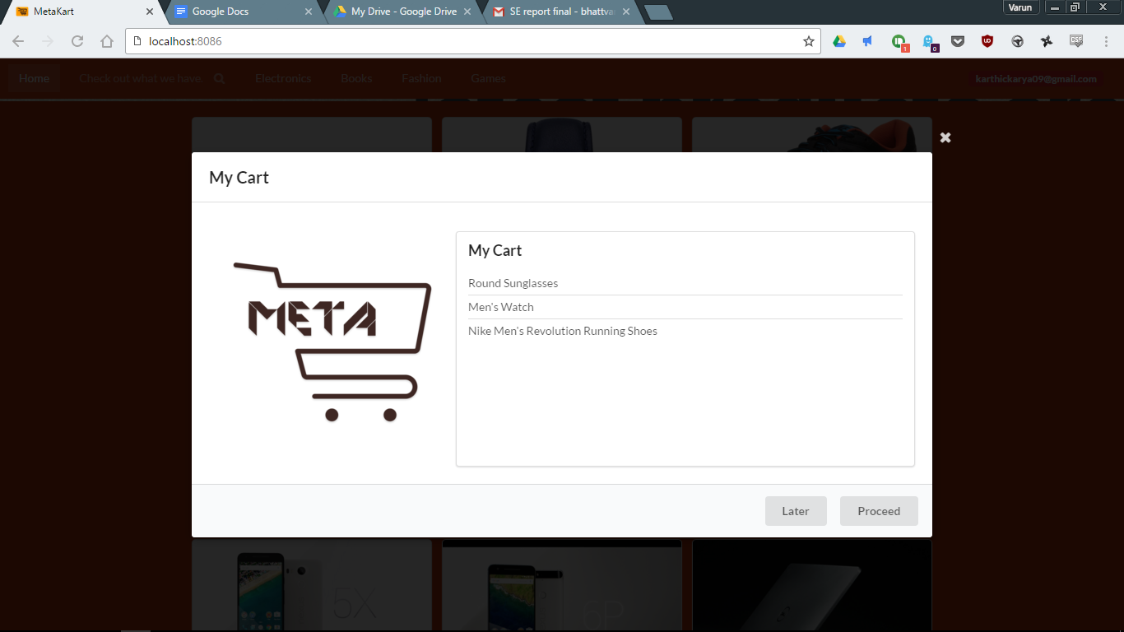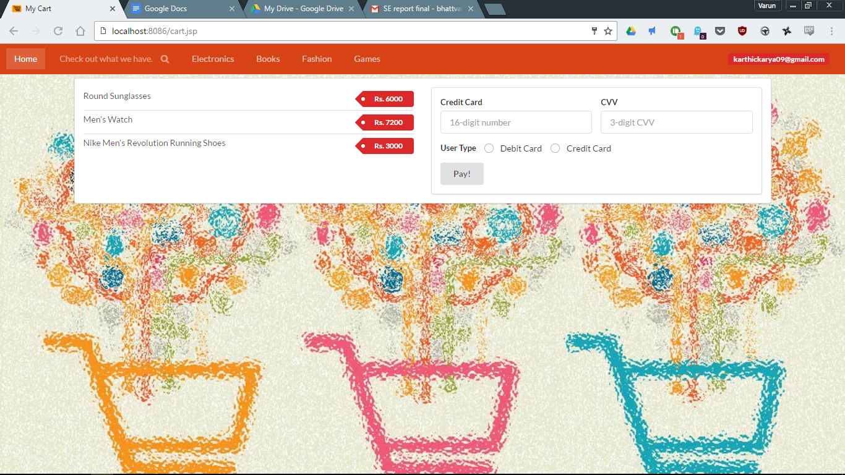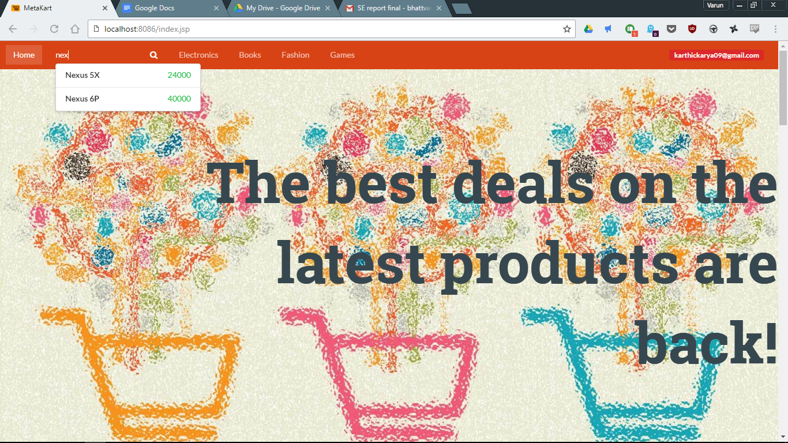

Conclusion:
For implementation of this project we did our requirement gathering first, which included all the types of requirements. The cost estimation methods were then done for our project, to have a brief idea about the project’s cost and personnel requirement. Then, risk analysis was done with the help of risk table and RMMM plan and found out all the potential risks for our project. Functional testing was done for our project to check the validation of the functions used. For completion of all the tasks above, a project schedule was used which had deadlines for each task. Thus our online shopping service - MetaKart was implemented successfully.

